Eyeconic - Glasses Shop Management System

Use-Case Specification: M30 - Add Categories

Version 1.0

Revision History

|  |  |  |  |
| --- | --- | --- | --- |
| **Date** | **Version** | **Description** | **Author** |
| 05/11/2019 | 1.0 | Start creating use case | Hoàng Tiến Long |
|  |  |  |  |
|  |  |  |  |
|  |  |  |  |

Table of Contents

1. Add Categories 4

1.1 Brief Description 4

1.2 Actor 4

2. Flow of Events 4

2.1 Basic Flow 4

2.2 Exception 4

2.2.1 Add category 4

2.2.2 Fill in the information form 5

2.2.3 Confirming adding the category 5

3. Special Requirements 5

4. Preconditions 5

4.1 Login 5

5. Postconditions 5

6. Extension Points 5

Use-Case Specification: Add Categories

# Add Categories

## Brief Description

This use cacse defines the step of adding new category.

Categories are added by the admin.

## Actor

Administrator.

# Flow of Events

## Basic Flow

In categories management, the system administration clicks the add button. The administrator fills in the information of the new Category. The system displays the updated management parameter value and logs the change.

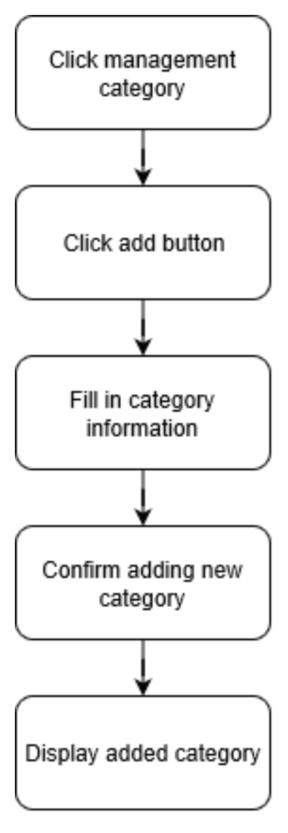

***Basic flow of adding category***

Step 1: Click management category.

Step 2: Click add button.

Step 3: Fill in category information.

Step 4: Confirm adding new category.

Step 5: Display added category.

## Exception

### Add category

The add button cannot be clicked or isn’t appeared on the screen

### Fill in the information form

Invalid information.

Must fill out all the information in the form.

### Confirming adding the category

The “Save” button is clicked but the new category is not added to the database.

This new category is existed in the database.

# Special Requirements

No Special Requirements

# Preconditions

## Login

Actor must already login as the administrator of the website

Accuracy is required when administrator want to add category.

# Postconditions

# Extension Points

No extension points.